SUMMERVILLE CREDIT UNION · CONSOLIDATED MEMBER GUIDE
Activate Card

Module: nFinia Digital Banking > More > Activate New Card
01 PRODUCT SUMMARY

The Activate Card feature allows you to activate a newly received debit or credit card directly through online banking — no phone call or branch visit required. Once your physical card arrives in the mail, you can activate it in just a few minutes by entering your membership, selecting the card type, and providing your 16-digit card number along with the expiration date.
Activation is required before your card can be used for purchases, ATM withdrawals, or any other card transactions. The process supports both debit and credit cards associated with your Summerville Credit Union membership. Once submitted, a confirmation screen displays the exact card name and number activated, and gives you direct shortcuts to your card list or the Dashboard.

At a Glance
Attribute | Detail
Module | nFinia Digital Banking > More > Activate New Card
Supported Card Types | Debit Card, Credit Card
Required Information | Membership, card type, 16-digit card number, expiration date (MM/YY)
Result | Card immediately activated and ready for use
Related Features | Deactivate / Replace Card, Set PIN, Card Controls

02 KEY USE CASES

Use Case | Who Uses It | What They Do | Business Value
Activate a new debit card | Member who received a new debit card in the mail | Selects membership and Debit Card type, enters card number and expiration, clicks Activate Card | Card is ready for immediate use without calling the credit union
Activate a new credit card | Member who received a new credit card | Selects Credit Card, enters the 16-digit number and expiry, submits | Instant self-service credit card activation from any device
Activate a replacement card | Member whose card was replaced due to loss or expiry | Re-activates the newly mailed replacement card through the same form | Restores card access quickly through digital self-service

03 STEP-BY-STEP GUIDE

Navigation: Log in to Summerville Credit Union online banking. From the Dashboard, click More in the top navigation bar, then select Activate New Card.
Step 1 — Arrive at the Dashboard
After logging in, you land on the Dashboard, which shows your account balances, recent payments, and quick-action shortcuts. The top navigation bar includes Home, Accounts, Transfers, Deposit Checks, Cards, Loans, eDocuments, and More. All card management tasks — including card activation — are accessible from this starting point.
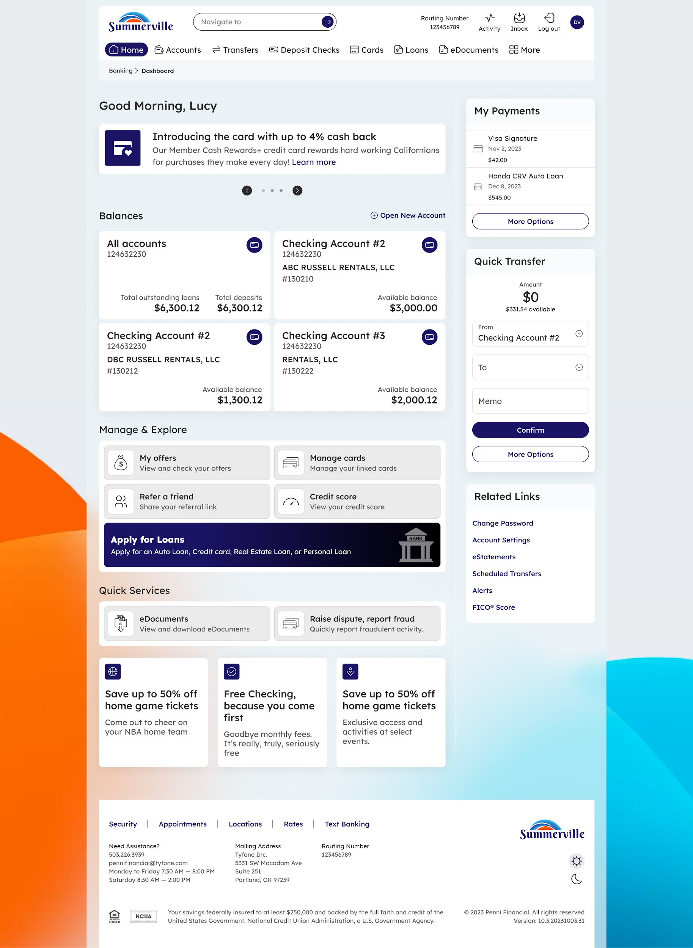
Step 1: Dashboard — your starting point for all card management tasks
Step 2 — Open the Activate New Card Form
Click More in the top navigation bar and select Activate New Card from the dropdown menu. The Activate New Card form opens with all required fields listed. You will see a membership selector dropdown at the top, followed by card type radio buttons (Debit Card or Credit Card), a field for your 16-digit card number, and expiration date fields for month and year.
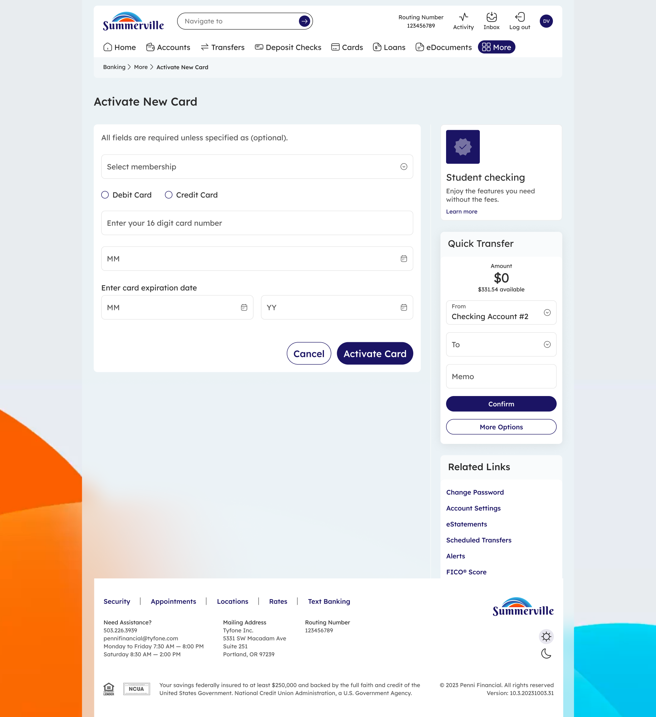
Step 2: Activate New Card form — select your membership and card type to begin
Step 3 — Enter Your Card Details and Submit
Select your membership from the dropdown, then choose Debit Card or Credit Card to match the card you received. Enter the full 16-digit card number printed on the front of your card, then enter the expiration date (month and year). Once all fields are complete, click Activate Card to submit. Click Cancel at any time to exit without activating.

Step 3: Card details filled in — click Activate Card to complete the process
Step 4 — Review the Activation Confirmation
A success screen appears confirming that your card has been activated. The message displays the full card name and masked card number — for example, "Your card Visa Signature (#190) #148879306 has been activated." From here, click Go to Cards to return to your card list, or click Go to Dashboard to return to the main banking dashboard.
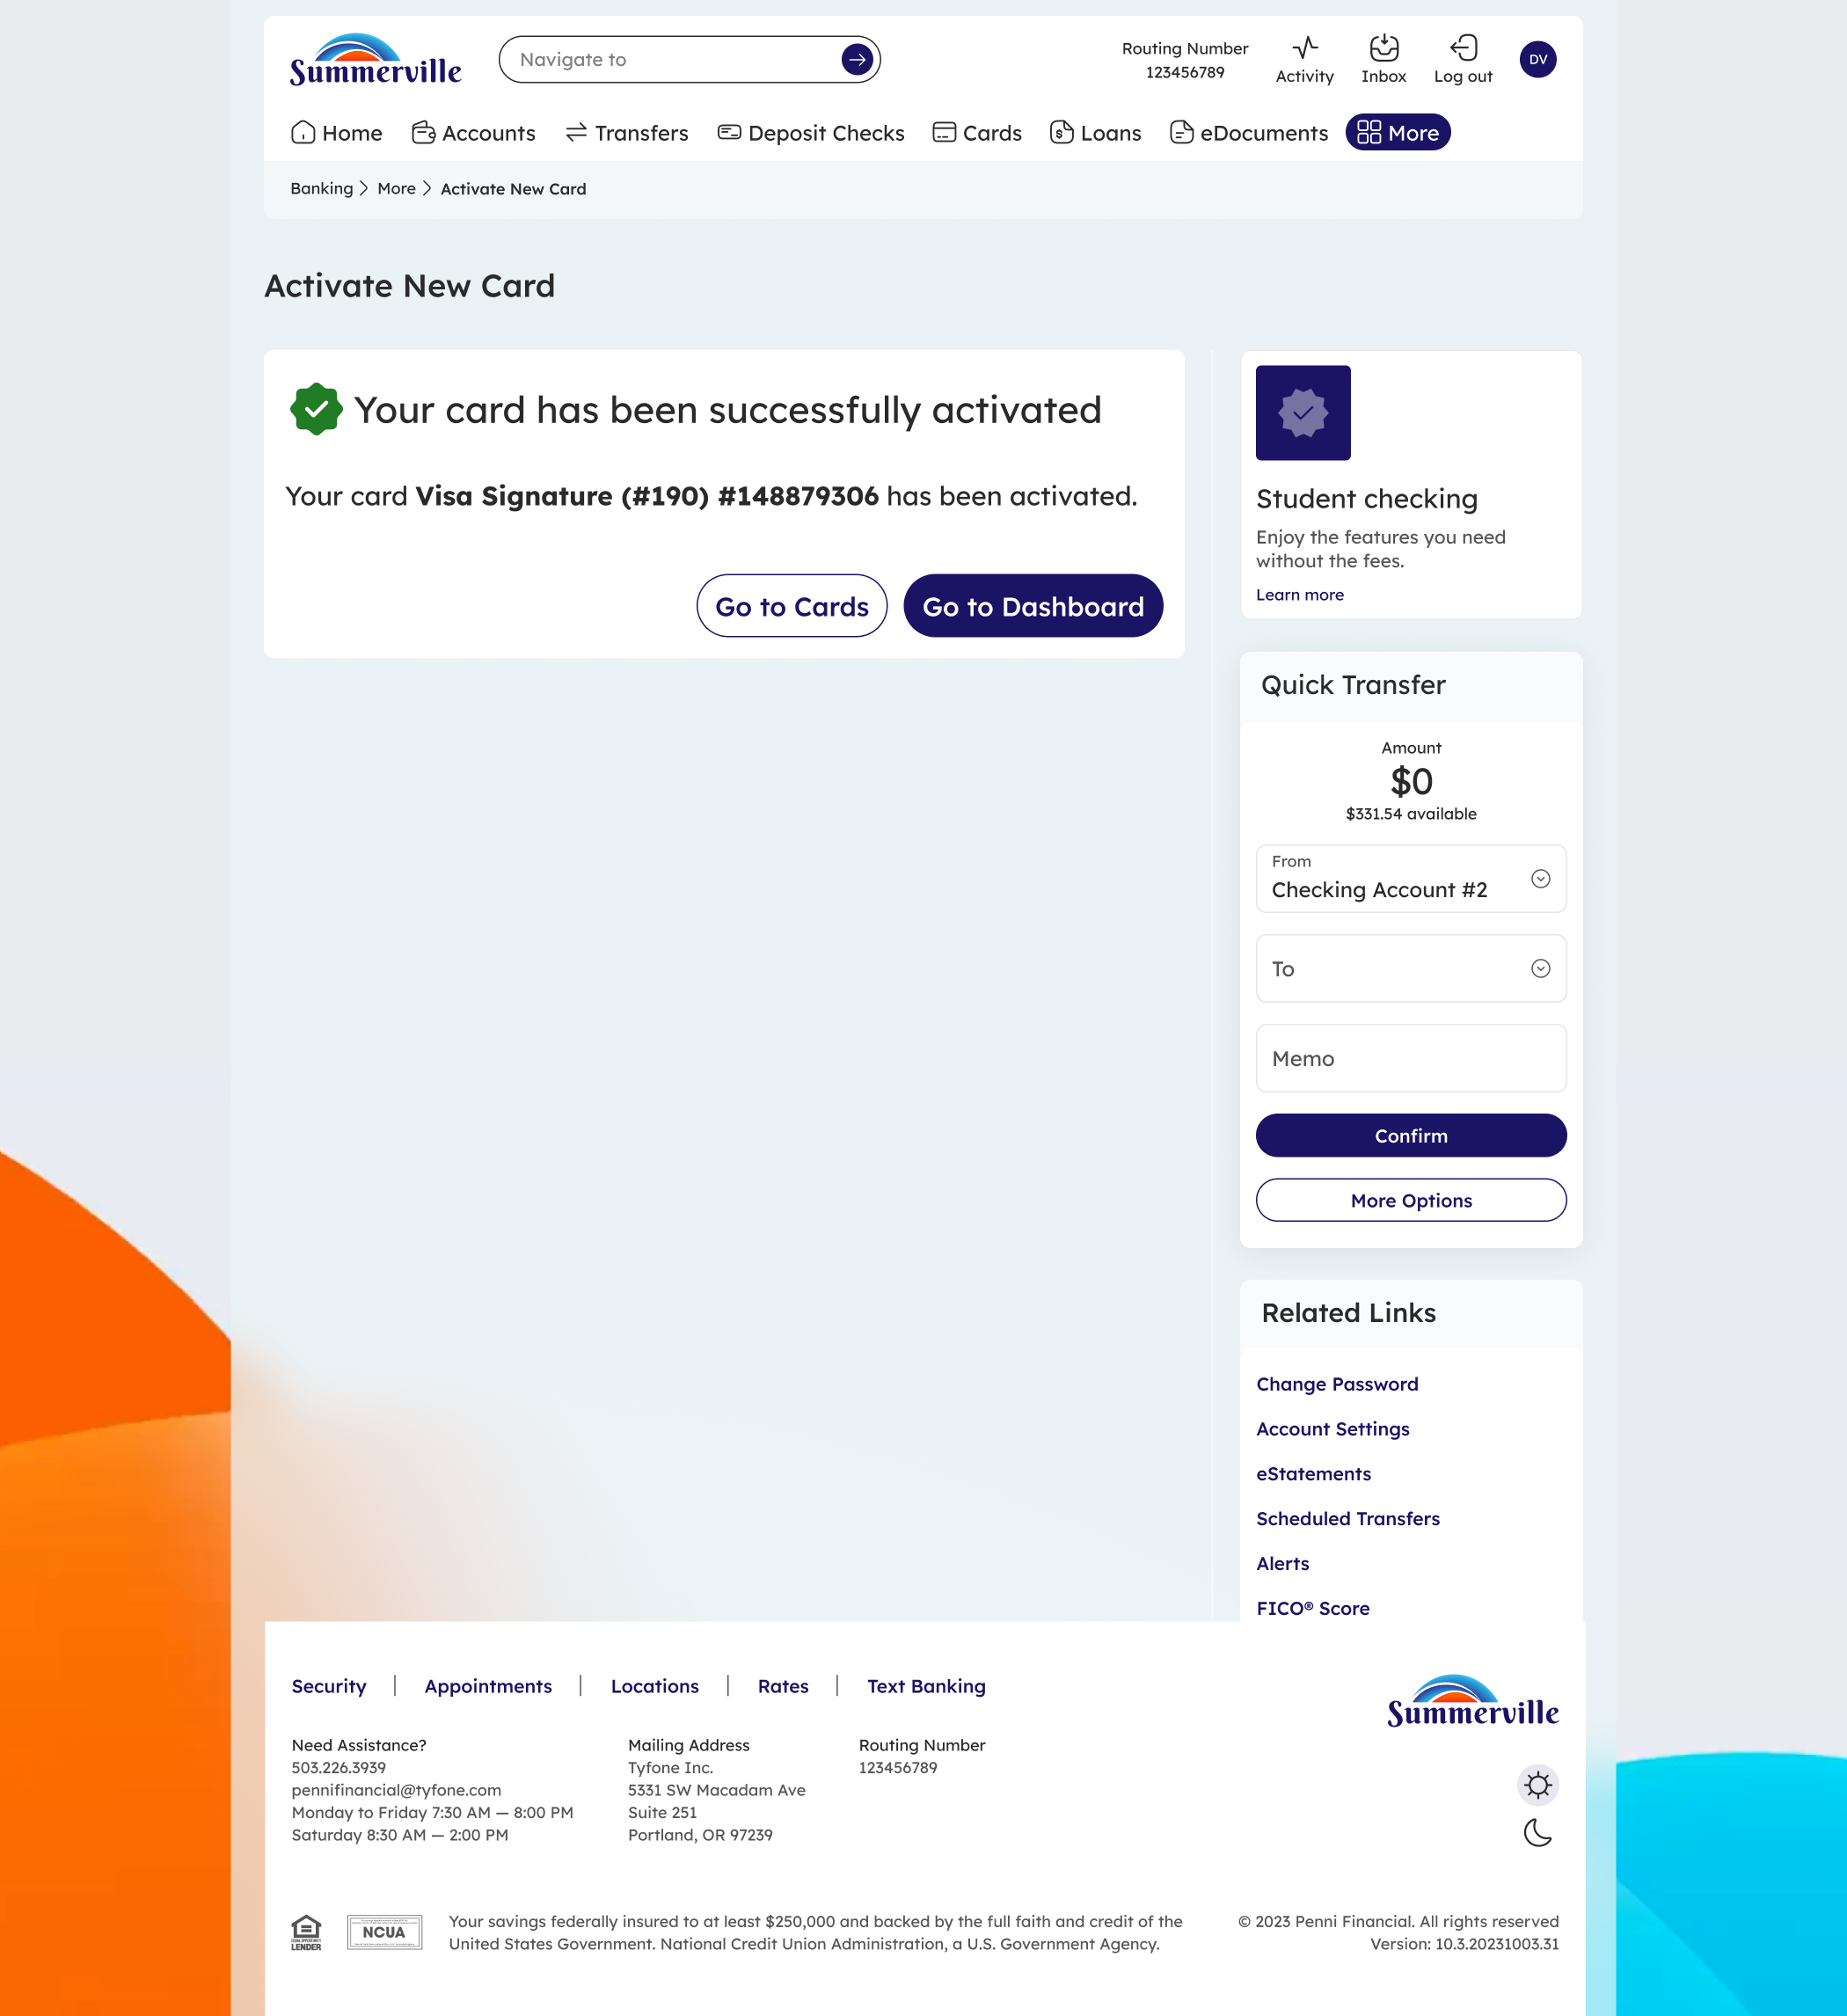
Step 4: Activation confirmed — your card is active and ready to use

